Exp No: 7
SERIAL COMMUNICATION USING ARDUINO WITH PROTEUS
AIM:
To write an Embedded C program for serial communication using Arduino Uno and Proteus
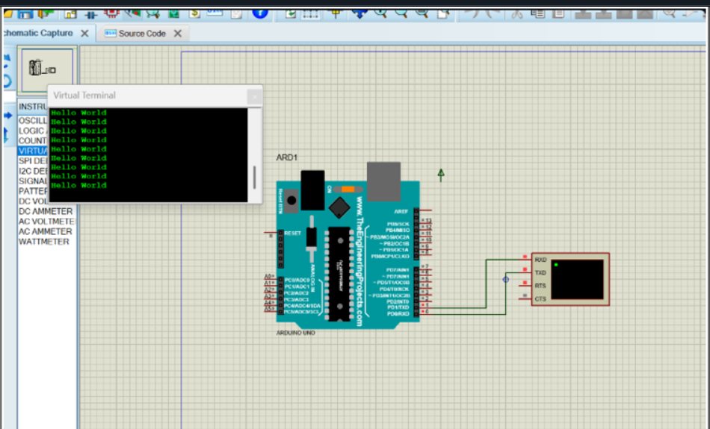

RESULT:
Thus the program has been successfully verified and executed

